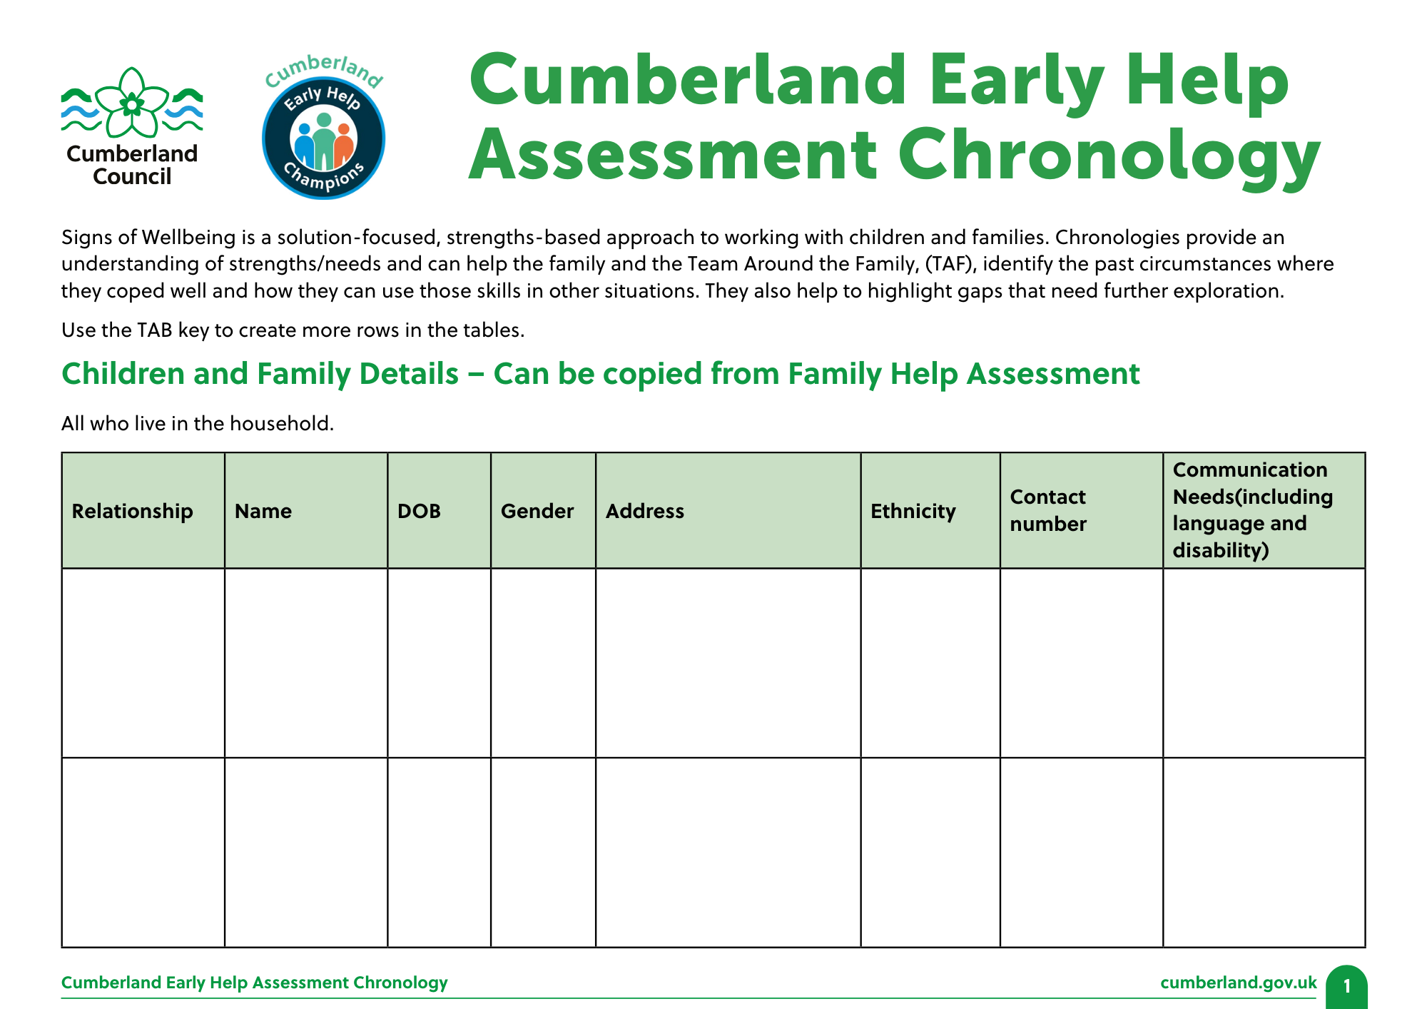
Cumberland Early Help Assessment Chronology

Signs of Wellbeing is a solution-focused, strengths-based approach to working with children and families. Chronologies provide an understanding of strengths/needs and can help the family and the Team Around the Family, (TAF), identify the past circumstances where they coped well and how they can use those skills in other situations. They also help to highlight gaps that need further exploration.

Children and Family Details – Can be copied from Early Help Assessment
All who live in the household.

Relationship | Name | DOB | Gender | Address | Ethnicity | Contact number | Communication Needs (including language and disability) | Education Setting
Choose an item. |  |  |  |  | Choose an item.
Choose an item. |  |  |  |  | Choose an item.
Choose an item. |  |  |  |  | Choose an item.
Choose an item. |  |  |  |  | Choose an item.
Choose an item. |  |  |  |  | Choose an item.
Choose an item. |  |  |  |  | Choose an item.
Choose an item. |  |  |  |  | Choose an item.

Who is completing this chronology?
Name | Role | Agency | Contact details | Date completed
Significant Event Date | Significant event Details | Impact on child or Young Person | Any Action taken | Outcome

Significant Event Date | Significant event Details | Impact on child or Young Person | Any Action taken | Outcome
